Game Design Document

Fill up the following document

1. Write the title of your project.

Pacman.

1. What is the goal of the game?

The goal of the game is to collect all the balls without getting eaten by ghosts.

1. Write a brief story of your game.

In this game there are some monsters protecting some powefull

Balls and you have to collect all the ball before the ghosts eat you 5

Time .Ghost will move all the time to make sure you you cannot collect ball so be protected from them and get all the balls.

1. Which are the playing characters of this game?

* Playing characters are the ones who respond to the user based on the input from the user.
* Cars, monkeys, dinos, wizards, etc., are the playing characters in the game.

|  |  |  |
| --- | --- | --- |
| Number | Character Name | What can this character do? |
| 1 | Pacman | This character can move with your arrow keys and take balls |
| 2 |  |  |
| 3 |  |  |
| 4 |  |  |
| 5 |  |  |
| 6 |  |  |
| 7 |  |  |
| 8 |  |  |

1. Which are the Non-Playing Characters of this game?

* Non-Playing characters are the ones that don't have an action or behavior when the user interacts with the game.
* Hurdles, stones, bananas, coins, etc., are non-playing characters in the game.

|  |  |  |
| --- | --- | --- |
| Number | Character Name | What can this character do? |
| 1 | Walls | This can not let you go from them |
| 2 | Ghosts | Ghost will try to kill you |
| 3 | Balls | You have to collect them |
| 4 |  |  |
| 5 |  |  |
| 6 |  |  |
| 7 |  |  |
| 8 |  |  |

Draw your imagination of this game. What does this game look like?

* Draw the game either on your computer or on paper.
* Add images of the game scenes to show each of the playing and non-playing characters at least once.

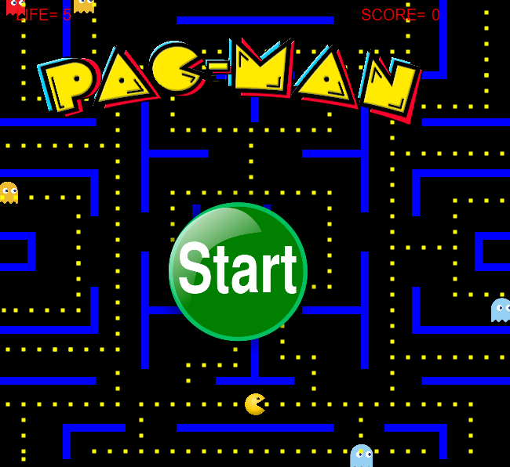

How do you plan to make your game engaging?

By Thinking